**My High School HOPE GPA**

Your Georgia [high school HOPE GPA](https://www.gafutures.org/hope-state-aid-programs/hope-zell-miller-scholarships/hope-scholarship/eligibility/hope-gpa-calculation/) starts calculating as soon as you begin 9th grade. Unlike your overall high school GPA, your HOPE GPA only includes your core curriculum courses:

* English
* Math
* Science
* Social Studies
* Foreign Language

You can begin checking your HOPE GPA through your *My GAfutures* account starting in the 10th grade.* Don’t have an account? It’s quick and easy to [create one](https://www.gafutures.org/create-account/)!

Your *My High School HOPE GPA* page includes your student information, your HOPE GPA as calculated by GSFC based on transcripts sent by your Georgia high school, rigor credits, ACT/SAT scores if you’ve taken them, and more information about the eligibility requirements of the [HOPE](https://www.gafutures.org/hope-state-aid-programs/hope-zell-miller-scholarships/hope-scholarship/) and [Zell Miller Scholarships](https://www.gafutures.org/hope-state-aid-programs/hope-zell-miller-scholarships/zell-miller-scholarship/).

*High schools must provide transcript data to GSFC in order for a student’s HOPE GPA to be available through their GAfutures account.

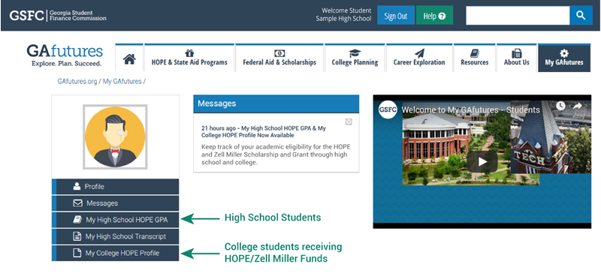

An example of a My GAfutures account homepage. Access*My High School HOPE GPA*and*My College HOPE Profile*from the left-side menu.

***My High School HOPE GPA* - Frequently Asked Questions**

**Q:** **Can high school students check their high school HOPE GPA?**

**A:** Yes, students enrolled at an eligible high school, located in Georgia, may check their high school HOPE GPA, by selecting the *My High School HOPE GPA* tab through their GAfutures account.

**Q:** **When will my final HOPE GPA post?**

**A:** Eligible public and private high schools, located in Georgia, must transmit enrolled student’s final transcript data to GSFC no later than June 30th each year.

**Q:** **Does GSFC need my ACT/SAT test scores?**

**A:** Yes, if you have a 3.7 or higher HOPE GPA, you may meet the academic eligibility requirements for the [Zell Miller Scholarship](https://www.gafutures.org/hope-state-aid-programs/hope-zell-miller-scholarships/zell-miller-scholarship/). GSFC must have your official ACT or SAT score report before a final determination can be made.

In order to meet the eligibility requirements, a student must graduate from an eligible high school with a minimum 3.7 grade point average (as calculated by GSFC) combined with a minimum score of 1200 on the math and reading portions of the SAT test or a minimum composite score of 26 on the ACT test in a single national test administration